Configure Passkey in Microsoft Authenticator

Objective
Configure a Passkey (access key) in the Microsoft Authenticator app to enable passwordless login to Contoso systems.

Prerequisites
- Microsoft Authenticator app installed on the mobile device.
- Contoso account already registered in Authenticator (see KB-009).

Step-by-Step
- Open the Microsoft Authenticator app on your mobile device. Confirm that the Contoso account is listed (e.g.: usuario@na.contoso.com — the domain may be NA, WZ, EU, or AP). Tap your account.
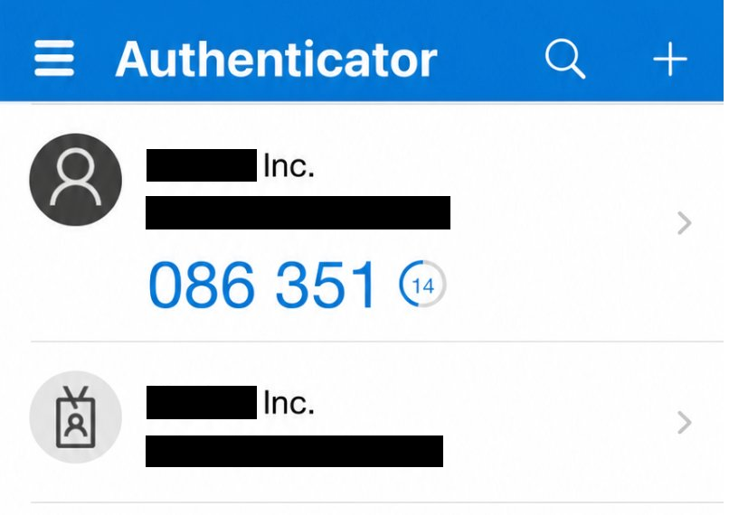
- On the account screen, select the Contoso account (just tap it) and on the next screen, tap Create a passkey.
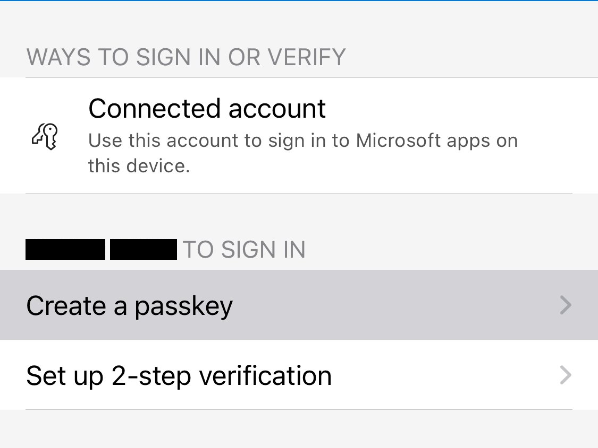
- On the next screen, tap Sign in to verify your identity and start creating the Passkey. You will be prompted to authenticate with your Contoso account.
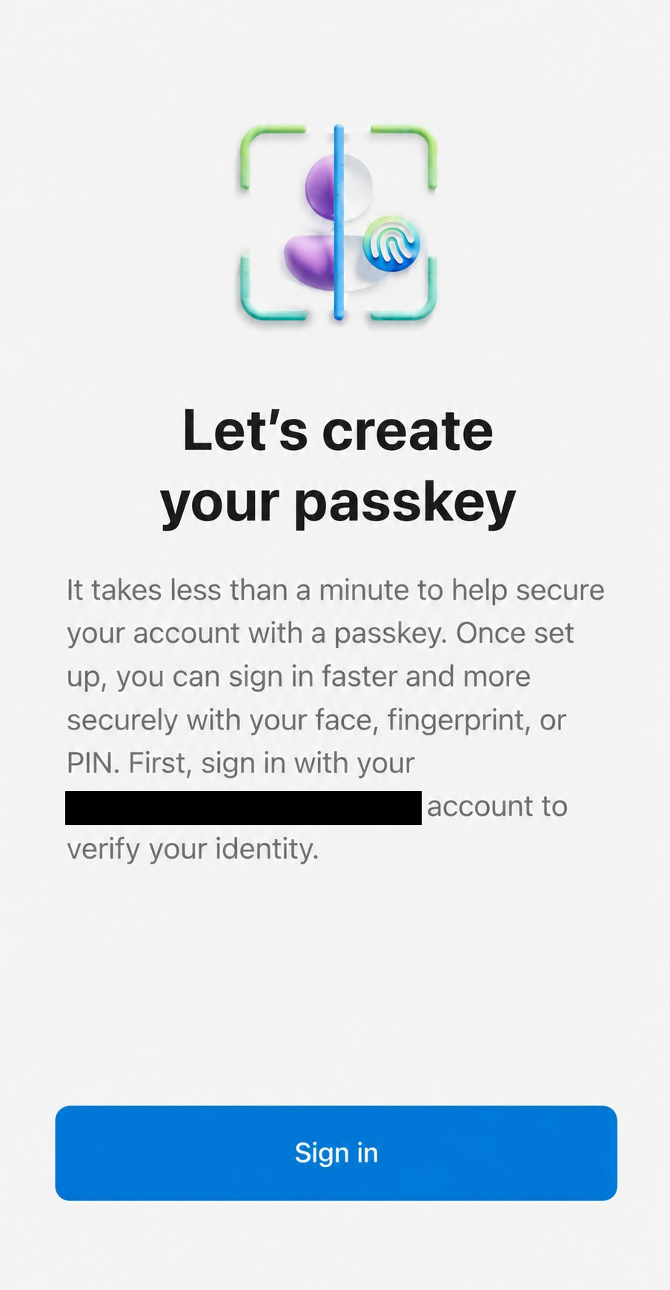
- Select the verification method "Approve a request on my Microsoft Authenticator app" (device biometrics).
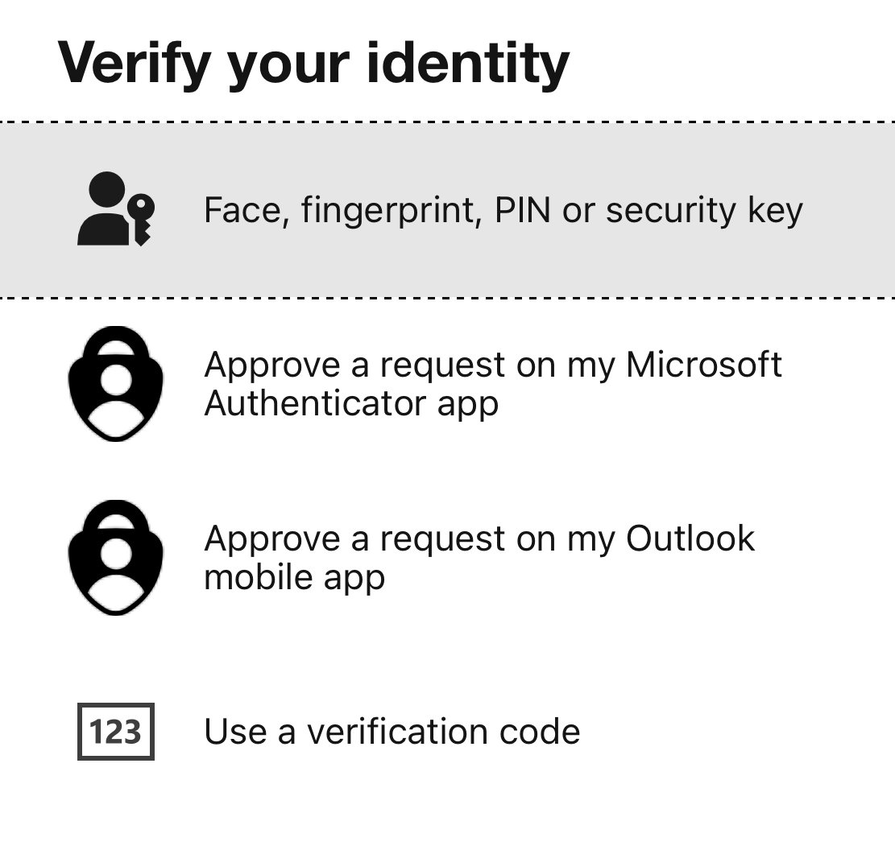
- After verification, the Passkey is created automatically. Tap Done to finish. From now on, use "Face, fingerprint, PIN or security key" at login and make sure the Authenticator is set as the Passkey provider.
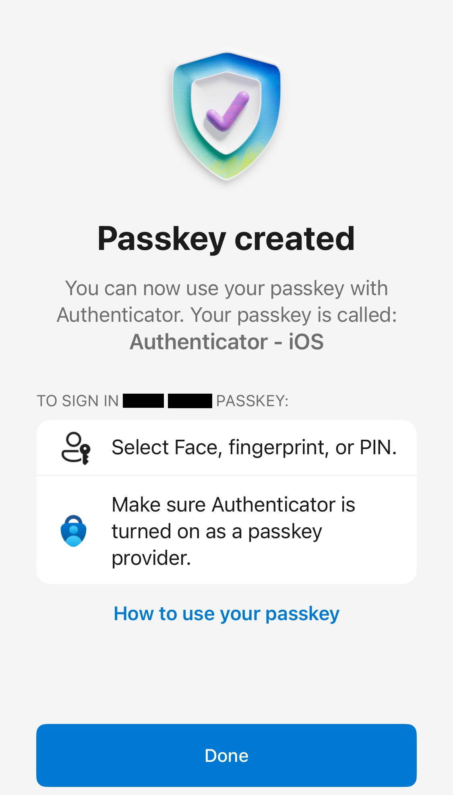

On the computer

- On the computer, when the Windows Security > Choose a passkey window appears, select "iPhone, iPad, or Android device":
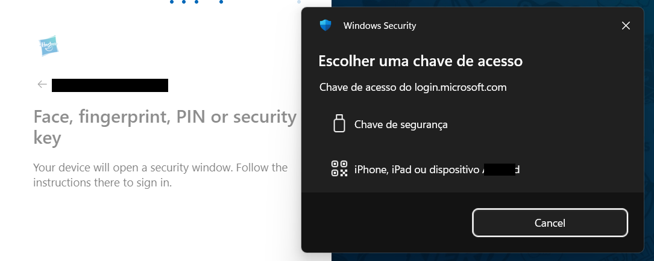
- The QR Code will be displayed on the computer screen. Scan it with your mobile device's camera:
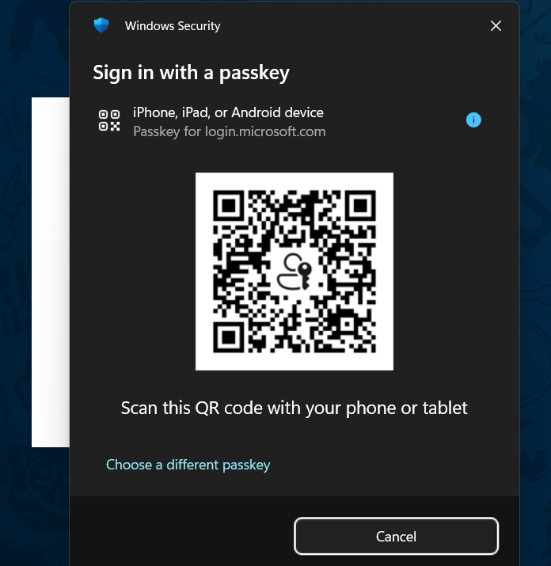
- After scanning, the computer will display the message Device connected! — continue approval on the mobile device:
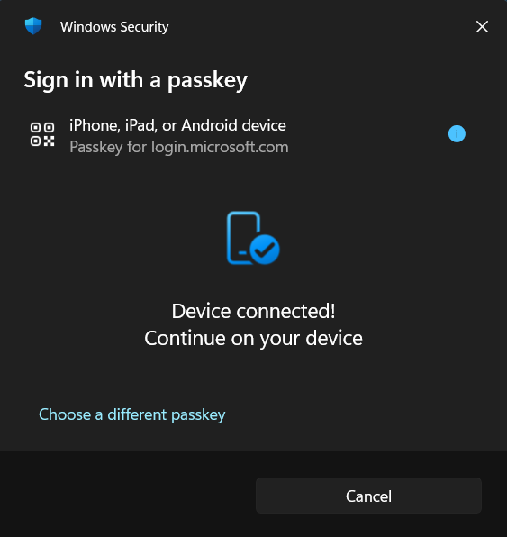

Version History
Author | Version | Date | Description
Lucas Souza | 1.0 | Jun/2026 | Document creation

